Para 5(2) of Investor Charter
Complaint Resolution process at Depositories⁹

Complaint Resolution process at Depositories
No amicable resolution
Complaint lodged with DP through electronic mode or physical mode
Place before Grievance Redressal Committee (GRC)
Client not satisfied with GRC order
Client not satisfied with Arbitration award
-Refer to arbitration
-Arbitration in clients favour
-Refer to Appellate arbitration
-award in clients favour
Client not satisfied with Appellate award
U/s 34 before Court
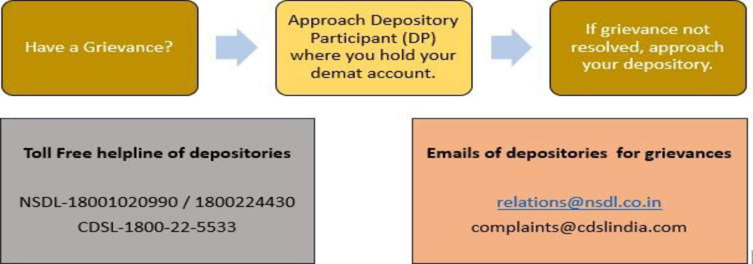

Investor Helpline Details of Depositories

